**Date :- 20-01-25**

**Day 1 task:- Data cleanisation**

**Step 1:-**

1)Open the power bi desktop app

2)Select Blank project and open it

3)Select get data option and select text/csv file

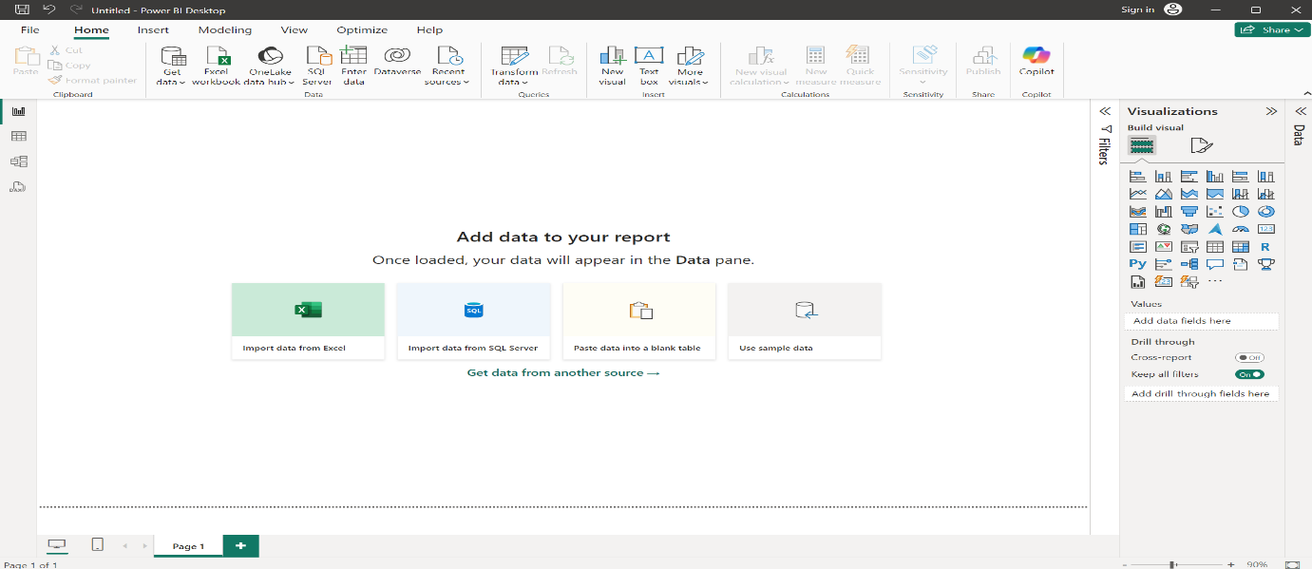

**Step 2:-**

1)Now after selecting the data source file the interface will be as given below

2)Now click on the load button to load the data into the power bi desktop

**Load :-**We use load when the data cleaned already

**Transform data:-**We use transform data is to remove the unwanted data,error, data null data

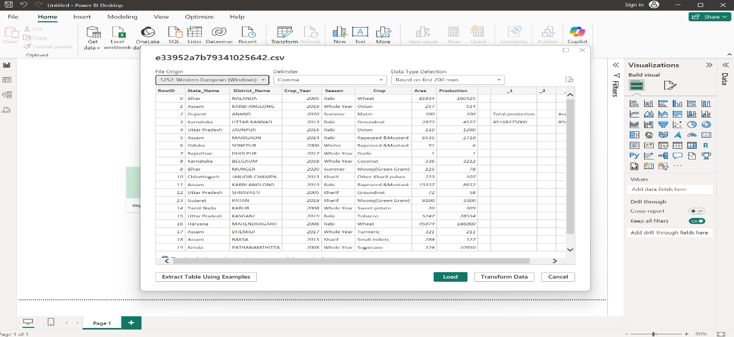

To make changes select the option transform data and the power query editor will be opened to remove unwanted data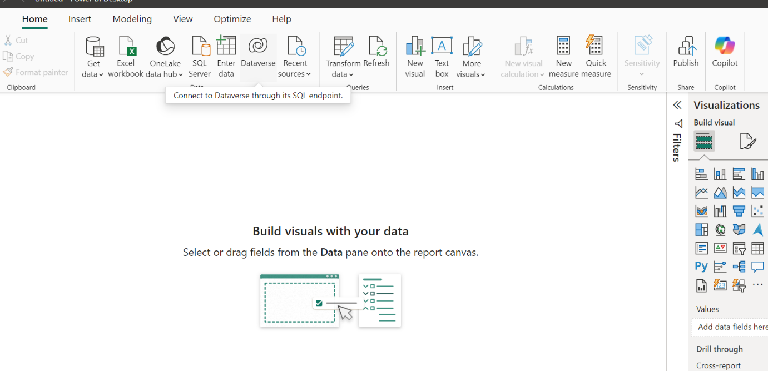

**Step 3:-**

1)Now remove unwanted data click right clicking on the unwanted row and selecting the remove.

2)After removing unwanted data click close and apply so the data will be saved without any unwanted data and errors

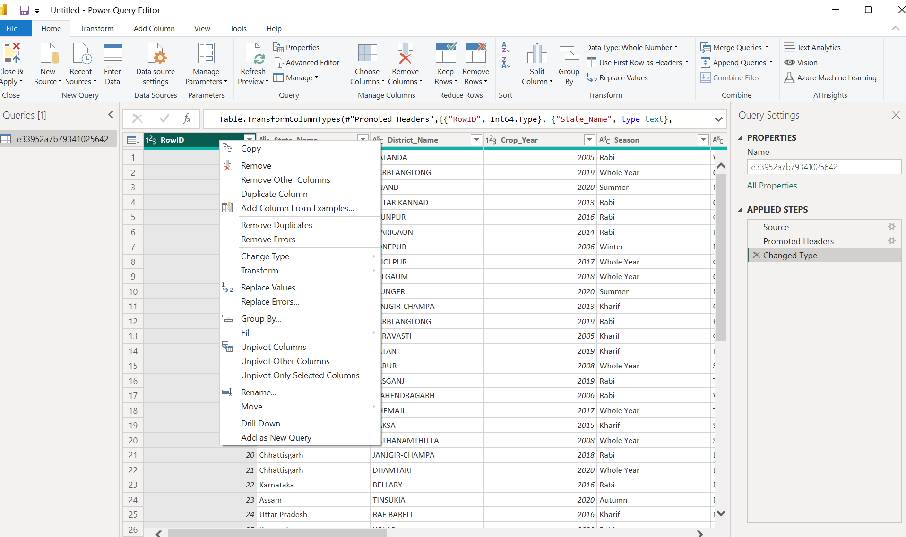

**Step 4:-**

The output at last will be shown in like this and it will be same as in table view also.

This is how data cleanisation is done in the powerbi desktop.

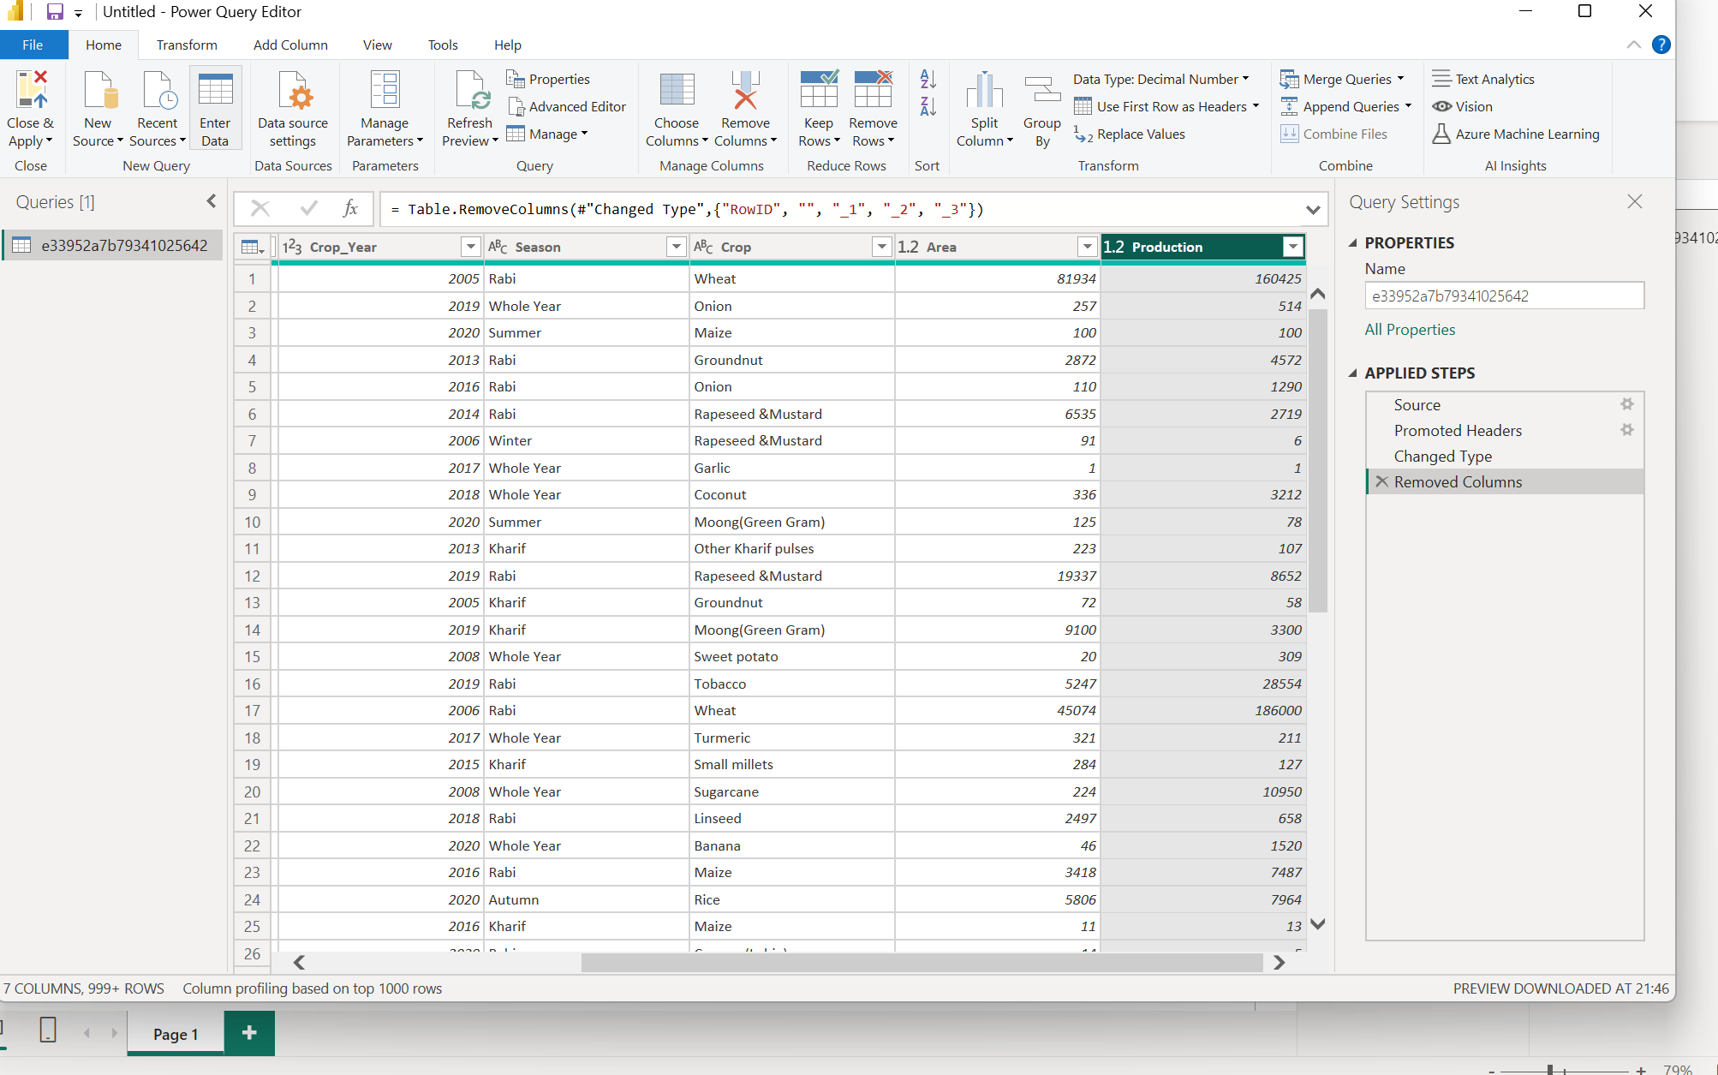

**Step 5:-**

We can also the column quality by clicking View 🡪 Select Column quality.Then it will show Valid,Error,Empty to show the quality .

